Performance Ratio: Metric for Reducing Operational Risk in Bitcoin Mining
In the previous article I wrote, I discussed a bitcoin mining property that I called the exhaust rate. This is the number that most people simply call “efficiency,” and its units are typically J/TH. A lot of that article was spent separating and measuring the real cost [in energy] for operating a miner to do a unit of work. Well, I hope that this article can be an extension of that previous article, but serve a more practical function. The idea introduced here is simpler, and should also take up a lot less space.
From my days as a solar engineer, we were familiar with a property called Performance Ratio (PR). It is a practical value that you can plot over time, in order to detect potential performance issues of the photovoltaic plant, and then investigate them. The metric not only allows an operator to diagnose and repair potential maintenance issues, but has an important role in the financial performance of the generating asset itself.
While the physical properties of the solar performance ratio are different, the fundamental quantities are the same:
performance ratio = yield factor / reference yield
PR = Yf / Yr
An explanation of the quantities follows:
- performance ratio: unitless quantity ranging from 0–1, or percentage from 0–100%
- yield factor: sometimes called “final yield.” this is the actual output of the asset, for a given input.
- reference yield: this is the expected yield of the asset, presuming it ran at its stated, or ideal performance
Recall that I previously named the “efficiency” of a miner the exhaust rate, a quantity denominated in J/TH (joules per terahash). Well, if we are talking about the nameplate specifications of a miner, we might call that value the reference exhaust rate (Er), and then introduce a quantity that is its inverse, which is most akin to a yield.
Er = Pr / Hr
Yr = 1 / Er = Hr / Pr
Where:
Er = exhaust rate, reference, in J/TH
Yr = yield, reference, in TH/J
Hr = nameplate hashrate, reference, in TH/s
Pr = nameplate power, reference, in W or J/s
Ex: Antminer S19 PRO, 110TH/s @ 3250W
Er = Pr / Hr = 3250W / 110 TH/s
= 29.5 J/TH
Yr = 1 / Er = 1 / (29.5 J/TH)
= 0.0339 TH/J
As you can see, we’ve introduced a new property called reference yield (Yr), and taken care of the denominator of our performance ratio equation. Again, what the reference yield describes is the amount of hashes that the miner can do for a given unit of energy input, in units of TH/J. It is the inverse of the exhaust rate.
For the numerator, yield factor (Yf), we need to know two additional quantities: 1) how many hashes were actually performed by the miner (W), and 2) how much energy it took to perform those hashes (G). The formula for such a quantity would look like this:
Yf = W / G
Where:
Yf = yield factor, or final yield
W = work, or terahashes (real)
G = energy, in joules (note: kWh x 3.6x10^6 = J)
Tying it all together, we get the following formula:
performance ratio = yield factor / reference yield
PR = Yf / Yr
= ( W / G ) / ( Pr / Hr )
= ( W / G ) / ( 1 / Er )
By plotting and monitoring the performance ratio over time, you will be able to see how a mining asset is performing. A sudden drop off in performance ratio can indicate the loss of a hashboard, a sub-optimal tuning, or even the loss of a unit entirely.
Here’s what a plot looks like in practice. In this case, the miner was deliberately rebooted and the plot displays the unit’s subsequent recovery over the following data samples. The data is aggregated hourly.
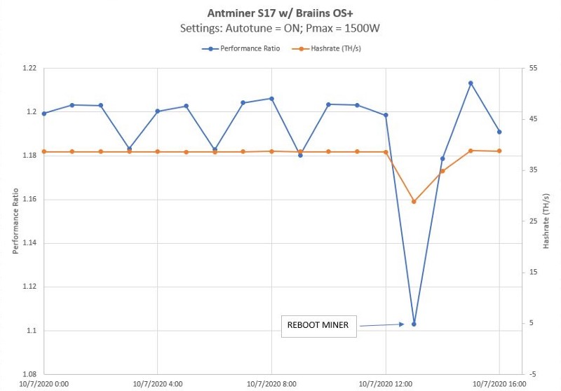
Miscellaneous notes:
- Because the performance ratio is really about establishing a performance baseline for our hardware, I would recommend leaving out the influences of mining pool or dev fees from the yield factory (Yf). While it would be nice to monitor the real dev fee and mining pool fees in order to keep our technology partners honest, this is not an issue we are going to solve here!
- Note that certain firmware versions will produce performance ratios greater than 100%, relative to the stock, reference yields. You could normalize this to a given value if you felt compelled to, but I think using the reference yield (Yr) as the value that come stock from the factory allows apples-to-apples comparisons, and indicates how well you are doing relative to the nameplate ratings of the machine. It creates a common reference point to compare firmwares from various vendors, for example.
- Note that the performance ratio does not say anything about the gross output of a miner (total number of hashes, relative to it capability). For this, I would recommend using a miner-adapted version of Capacity Factor, which I explain in the next article: Bitcoin Mining Efficiency Series (Part 3): Capacity Factor
- Credit is due to the developers over at Braiins that created an API to query miners using their firmware. Click through for docs on the bosminer API. I will share a simple script I wrote that uses this API to log things like hashrate in another article.
I hope you found this article helpful. While I agree that eyeballing the hashrate at any given time will give you much of the information you need to know about a miner, it lacks a common reference point. The performance ratio creates this reference point, and allows a user to quickly compare relative performance across various firmwares, or even different miner hardware.

